727721EUIT011

ARCHANA M

SKCET-TESTING

CC1

1)

package com.Help.Sample;

import org.openqa.selenium.By;

import org.openqa.selenium.WebDriver;

import org.openqa.selenium.chrome.ChromeDriver;

import org.openqa.selenium.chrome.ChromeOptions;

import io.github.bonigarcia.wdm.WebDriverManager;

public class CC_Ques1 {

public static void main(String[] args) throws InterruptedException {

ChromeOptions co=new ChromeOptions();

co.addArguments("--remote-allow-origins=*");

WebDriverManager.*chromedriver*().setup();

WebDriver driver=new ChromeDriver();

driver.get("https://www.saucedemo.com/");

//user login

driver.findElement(By.*xpath*("//*[@id=\"user-name\"]")).click();

driver.findElement(By.*xpath*("//*[@id=\"user-name\"]")).sendKeys("standard_user");

driver.findElement(By.*xpath*("//*[@id=\"password\"]")).click();

driver.findElement(By.*xpath*("//*[@id=\"password\"]")).sendKeys("secret_sauce");

driver.findElement(By.*xpath*("//*[@id=\"login-button\"]")).click();

//Adding to cart

Thread.*sleep*(2000);

driver.findElement(By.*xpath*("//*[@id=\"add-to-cart-sauce-labs-backpack\"]")).click();

String num=driver.findElement(By.*xpath*("//*[@id=\"shopping_cart_container\"]/a/span")).getText();

if(num.equals("1")){

System.***out***.println("Item added to cart");

}

//Viewing cart items

Thread.*sleep*(2000);

driver.findElement(By.*xpath*("//*[@id=\"shopping_cart_container\"]/a")).click();

String act=driver.findElement(By.*xpath*("//*[@id=\"header_container\"]/div[2]/span")).getText();

if(act.equals("Your Cart")) {

System.***out***.println("User can view contents in cart");

}

//checkout

Thread.*sleep*(2000);

driver.findElement(By.*xpath*("//*[@id=\"checkout\"]")).click();

String ac=driver.findElement(By.*xpath*("//*[@id=\"header_container\"]/div[2]/span")).getText();

if(ac.equals("Checkout: Your Information")) {

System.***out***.println("Your information is displayed");

}

//Filling form

driver.findElement(By.*xpath*("//*[@id=\"first-name\"]")).click();

driver.findElement(By.*xpath*("//*[@id=\"first-name\"]")).sendKeys("Shyam");

driver.findElement(By.*xpath*("//*[@id=\"last-name\"]")).click();

driver.findElement(By.*xpath*("//*[@id=\"last-name\"]")).sendKeys("Sundar");

driver.findElement(By.*xpath*("//*[@id=\"postal-code\"]")).click();

driver.findElement(By.*xpath*("//*[@id=\"postal-code\"]")).sendKeys("621005");

Thread.*sleep*(2000);

driver.findElement(By.*xpath*("//*[@id=\"continue\"]")).click();

String actu=driver.findElement(By.*xpath*("//*[@id=\"header_container\"]/div[2]/span")).getText();

if(actu.equals("Checkout: Overview")) {

System.***out***.println("Overview of the products displayed");

}

//Details of the products

String name=driver.findElement(By.*xpath*("//*[@id=\"item_4_title_link\"]/div")).getText();

System.***out***.println("Name of the product: "+name);

String price=driver.findElement(By.*xpath*("//*[@id=\"checkout_summary_container\"]/div/div[1]/div[3]/div[2]/div[2]/div")).getText();

System.***out***.println("Price of the product: "+price);

//Asserting the title

String actual=driver.getTitle();

if(actual.equals("Swag Labs")) {

System.***out***.println("Title of the page is asserted");

}

//Asserting the url

String a=driver.getCurrentUrl();

if(a.equals("https://www.saucedemo.com/checkout-step-two.html")) {

System.***out***.println("URL of the page asserted");

}

driver.findElement(By.*xpath*("//*[@id=\"finish\"]")).click();

System.***out***.print("Thanks for Ordering!!Come back soon");

}

}

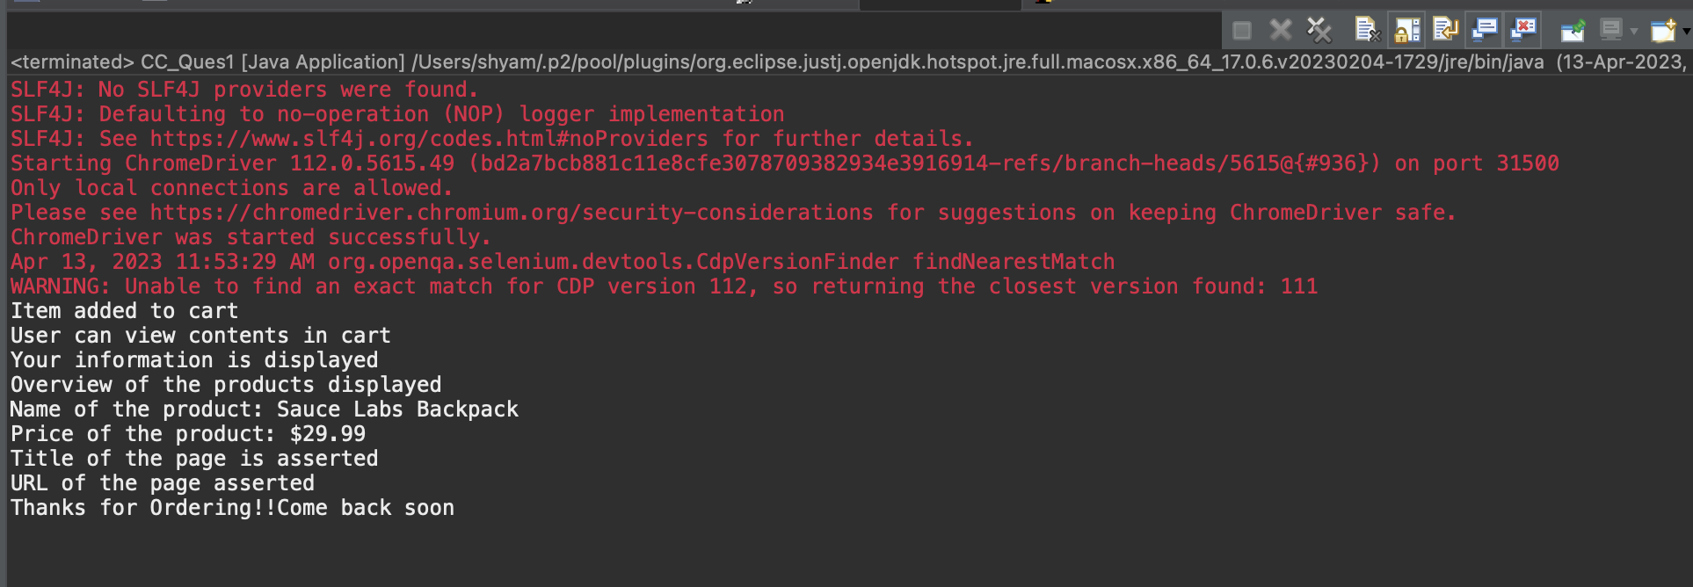

2)

package com.Help.Sample;

import org.openqa.selenium.By;

import org.openqa.selenium.WebDriver;

import org.openqa.selenium.chrome.ChromeDriver;

import org.openqa.selenium.chrome.ChromeOptions;

import io.github.bonigarcia.wdm.WebDriverManager;

public class CC_Ques2 {

public static void main(String[] args) {

ChromeOptions co=new ChromeOptions();

co.addArguments("--remote-allow-origins=*");

WebDriverManager.*chromedriver*().setup();

WebDriver driver=new ChromeDriver();

driver.get("https://www.saucedemo.com/");

//user login

driver.findElement(By.*xpath*("//*[@id=\"user-name\"]")).click();

driver.findElement(By.*xpath*("//*[@id=\"user-name\"]")).sendKeys("standard_user");

driver.findElement(By.*xpath*("//*[@id=\"password\"]")).click();

driver.findElement(By.*xpath*("//*[@id=\"password\"]")).sendKeys("secret_sauce");

driver.findElement(By.*xpath*("//*[@id=\"login-button\"]")).click();

//Filtering A-Z

System.***out***.println("First product from A-Z: "+driver.findElement(By.*xpath*("/html/body/div/div/div/div[2]/div/div/div/div[1]/div[2]/div[1]/a/div")).getText());

//Filtering Z-A

driver.findElement(By.*xpath*("/html/body/div/div/div/div[1]/div[2]/div/span/select")).click();

driver.findElement(By.*xpath*("/html/body/div/div/div/div[1]/div[2]/div/span/select/option[2]")).click();

System.***out***.println("First product from Z-A: "+driver.findElement(By.*xpath*("/html/body/div/div/div/div[2]/div/div/div/div[1]/div[2]/div[1]/a/div")).getText());

//Filtering low to high

driver.findElement(By.*xpath*("/html/body/div/div/div/div[1]/div[2]/div/span/select")).click();

driver.findElement(By.*xpath*("/html/body/div/div/div/div[1]/div[2]/div/span/select/option[3]")).click();

System.***out***.println("First product from low to high: "+driver.findElement(By.*xpath*("/html/body/div/div/div/div[2]/div/div/div/div[1]/div[2]/div[1]/a/div")).getText());

//Filtering high to low

driver.findElement(By.*xpath*("/html/body/div/div/div/div[1]/div[2]/div/span/select")).click();

driver.findElement(By.*xpath*("/html/body/div/div/div/div[1]/div[2]/div/span/select/option[4]")).click();

System.***out***.println("First product from Z-A: "+driver.findElement(By.*xpath*("/html/body/div/div/div/div[2]/div/div/div/div[1]/div[2]/div[1]/a/div")).getText());

}

}

